Introduction to AI

Image styling with genetic algorithms

by Danil Kalinin B17-05 Innopolis University

20 March 2019

[GitHub page](https://github.com/CurlySpeaker/image_generation_ea)

Introduction

Artificial intelligence is developing rapidly for the last 8 years. Mostly it is connected to the fact that we have stored huge amounts of data is well as increased computational power, especially GPU power. Although, nowadays the most hyped AI part is Deep Learning algorithms it is mostly applicable only for tasks where we have big datasets. If we have a task, where we need to process some kind of data having for example only 1 example (picture) it is almost impossible to train some kind of net unless ENN (evolutionary neural network). Therefore, we have to step back and think about simpler ways of solving the problem. In this paper I am going to describe on of the ways of solving that problem - Evolutionary Algorithms and show how to style (generate) the image using evolutionary algorithms.

Problem

*Having only* ***one*** *image(eg 512x512 px) we need to style it some way to create an art.*

This is a well known problem and it has been solved by lots of people sing different techniques. The most popular one is to generate random shapes (polygons, circles, dots) and drawing them. In this approach individual can be an image with some amount of shapes, genes - shapes themselves, and population is several images. Because this approach is well known I decided to implement it as basic and implement another one, something different to draw contours of image (edges) in grayscale.

Instruments

As instruments I decided to use Python3 as main language, Numpy for fast matrix operations and OpenCV for image processing. Moreover, I decided to use IPython notebooks because it has native support for Matplotlib needed for me to show the results live.

Solution

I decided to test 2 approaches:

First one is classical approach to generate image from dots, circles, rectangles.

Second one to create contours of the image and process them with evolution of lines.

Part 1 - Evolution of shapes

This approach is quite common in sense of generating images with evolution algorithms. The idea is to evolve picture with some shapes like circles, rectangles, polygons, lines, etc. Let's consider some definitions, that were used in this particular algorithm.

**Mutation** - with some probability we add new shapes on images with random opacity.

**Crossover** - we take 2 random pictures and merge them with random opacity for each other.

**Selection** - selecting some portion of images that fits best

**Loss function** -for this algo I decided to use simple MSE(mean squared error) between target image and generated one. Later in second algo I will describe some more metrics that could be used.

The epoch itself:

1. Make some amount of copies of base individual (on start just zero matrix)
2. Randomly create some amount of shapes on them
3. Crossover them to gain some more images
4. Select best one, make him base
5. Go to step 1 until good quality

Results

1. MSE

Triangles

Population size 10

Number of random shapes (1-5)

Time per epoch ~1s

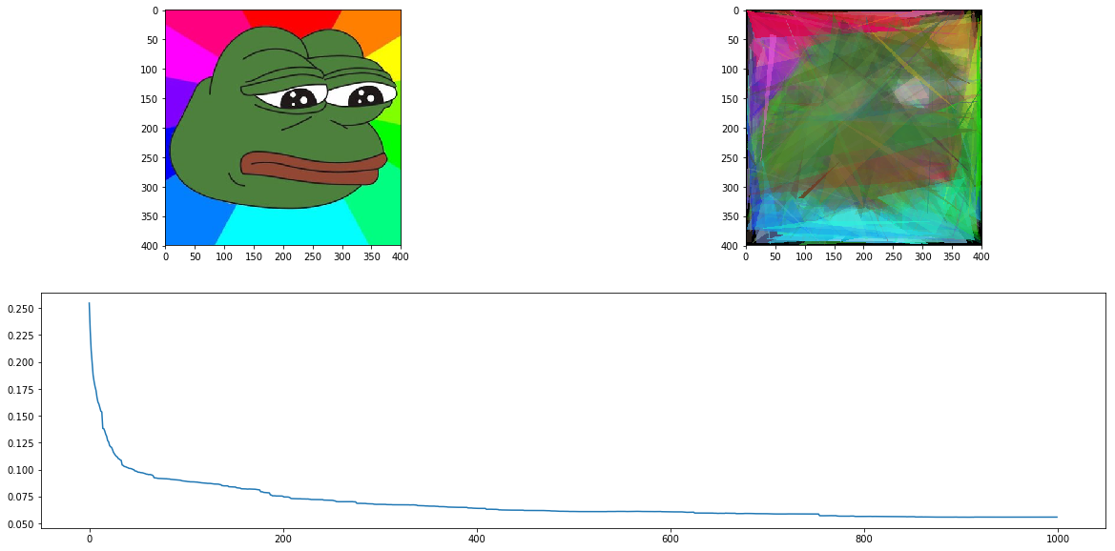

1. MSE

Circles, radius from 5-20

Population size 10

Number of random shapes (1-3)

Time per epoch ~1s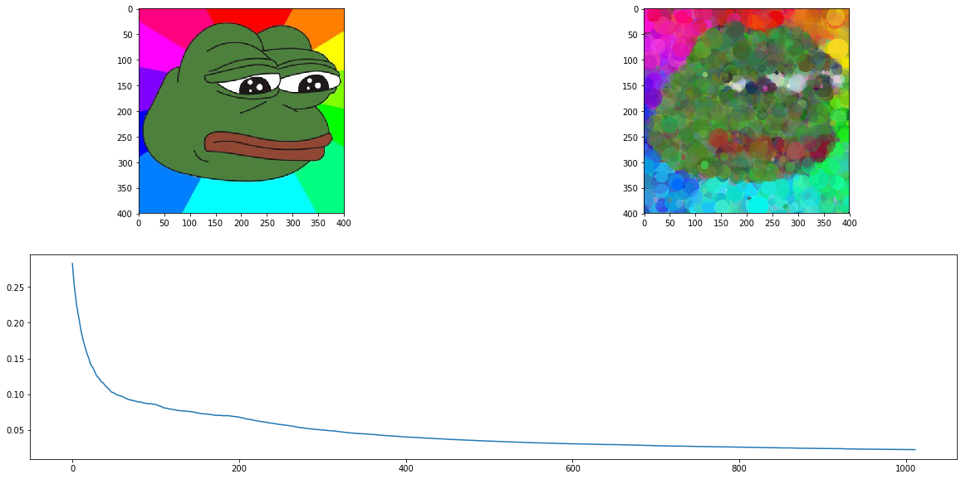

1. MSE

Circles, radius from 5-20

Population size 10

Number of random shapes (3-5)

Time per epoch ~1s

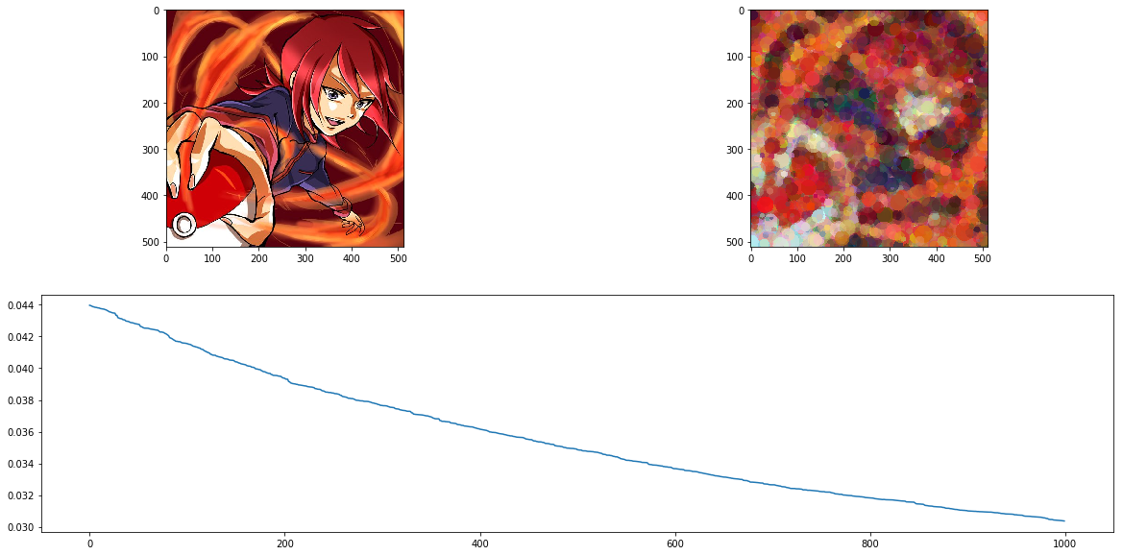

Part 2 - Evolution of lines

This approach consists of 3 main parts:

1. image preprocessing
2. edge detection
3. evolution of lines to create an image

Image preprocessing and edge detection

There are 3 main parts in image preprocessing. Firstly, we need to rescale so that we do not run our algorithm on very large image and run out of memory and time. Secondly, we need to make it grayscale for the simplicity of algorithm. Finally, we need to detect edges which then will be imitated by our evolutionary algorithm. First two parts is simple and I will not cover them in this report, nevertheless they are described in github repository of the project. The last one needs more attention. In my work I tried 2 detectors: Sobel operators and Laplacian operators. The basic idea of both of algos is to use gradients of image colors to find edges. In technical view it is about considering our image as matrix and applying convolving them with corresponding kernels to find edges.

Sobel kernels

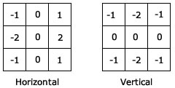

Laplacian kernel 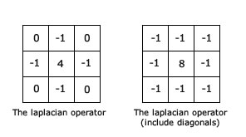

In final version I decided to use Laplacian kernel owing to the fact that it turned out to make more accurate edges on my tests.

Evolution part

I decided to solve the problem in following way. Consider as individual segment on picture. Its genes are (x1,y1,x2,y2, thickness). Population - set of such segments.

**Mutation** - with some probability regenerate one or more parameters of particular individ.

**Crossover** - in crossover I took 2 parents (2 segments) and merged their parameters (genes) to create new child. However crossover neither improved the speed of convergence nor the speed of iteration. Therefore I decided not to use it in final version of generator.

**Selection** - selecting some portion of individs which will come to next iteration.

**Loss function** -this one is used to understand how each individual is good or bad. I have tested several loss functions for individs, including Mean Average Error, Mean Squared Error and Intersection Over Union. Although, all of them are appropriate for problem domain, IoU has the fastest convergence speed. Different results from metrics will be shown later.

The epoch itself:

1. Select portion of best individs from population by the loss function
2. Crossover them and create children
3. Mutate children
4. Assign best portion and children to new pop
5. Go to step 1 until reach appropriate loss

Results

1. IoU

Population 3000

Length of line 10-40

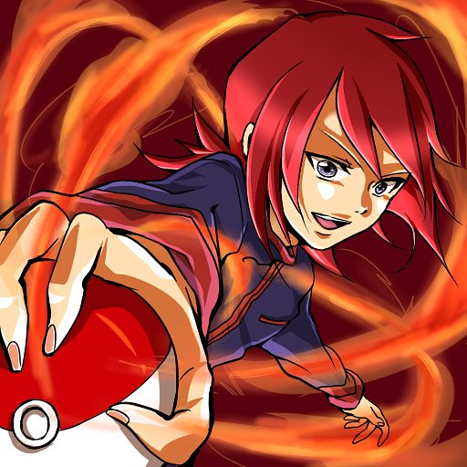

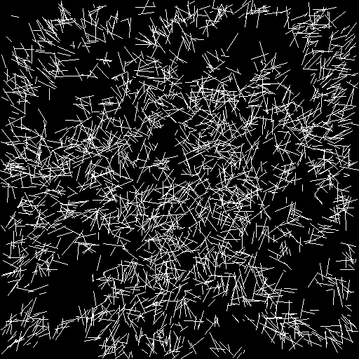

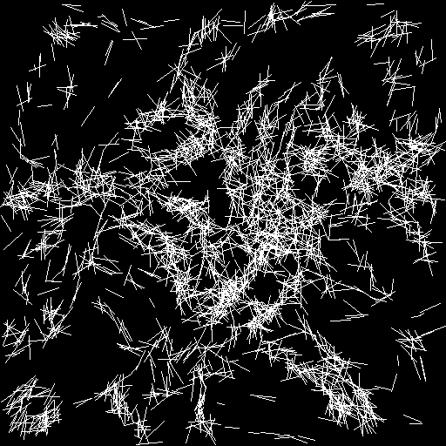

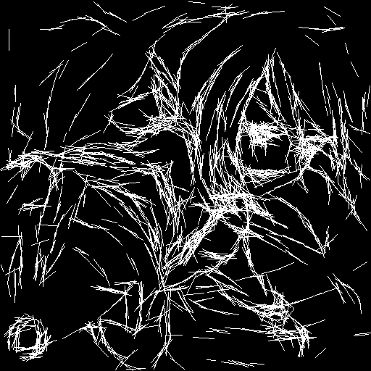

2. MSE

Population 4000

Length 1-5



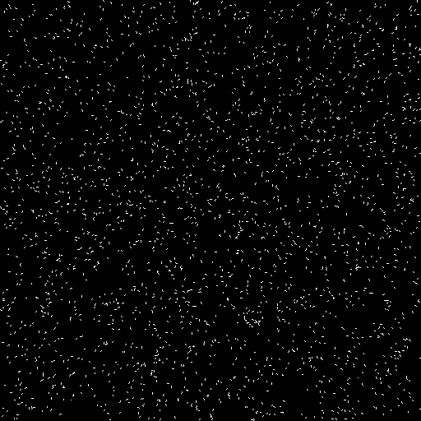

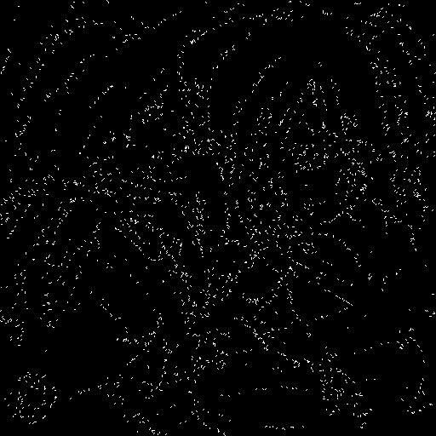

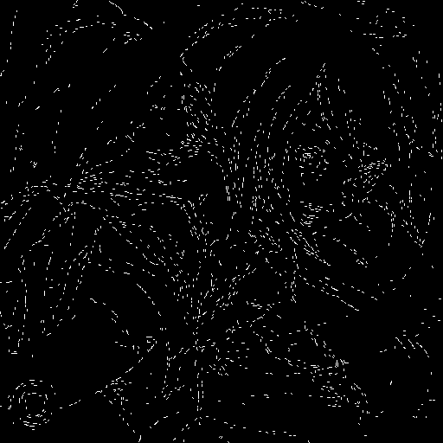

3. IoU

Population 5000

Length 5-20

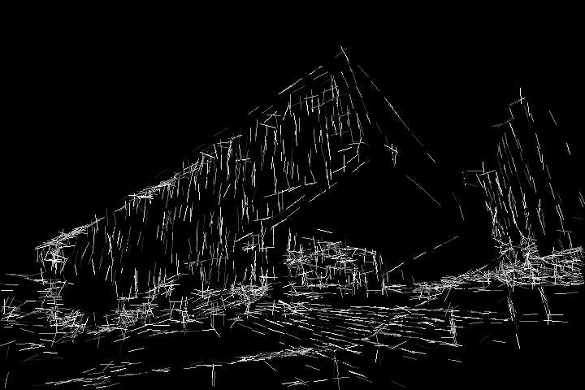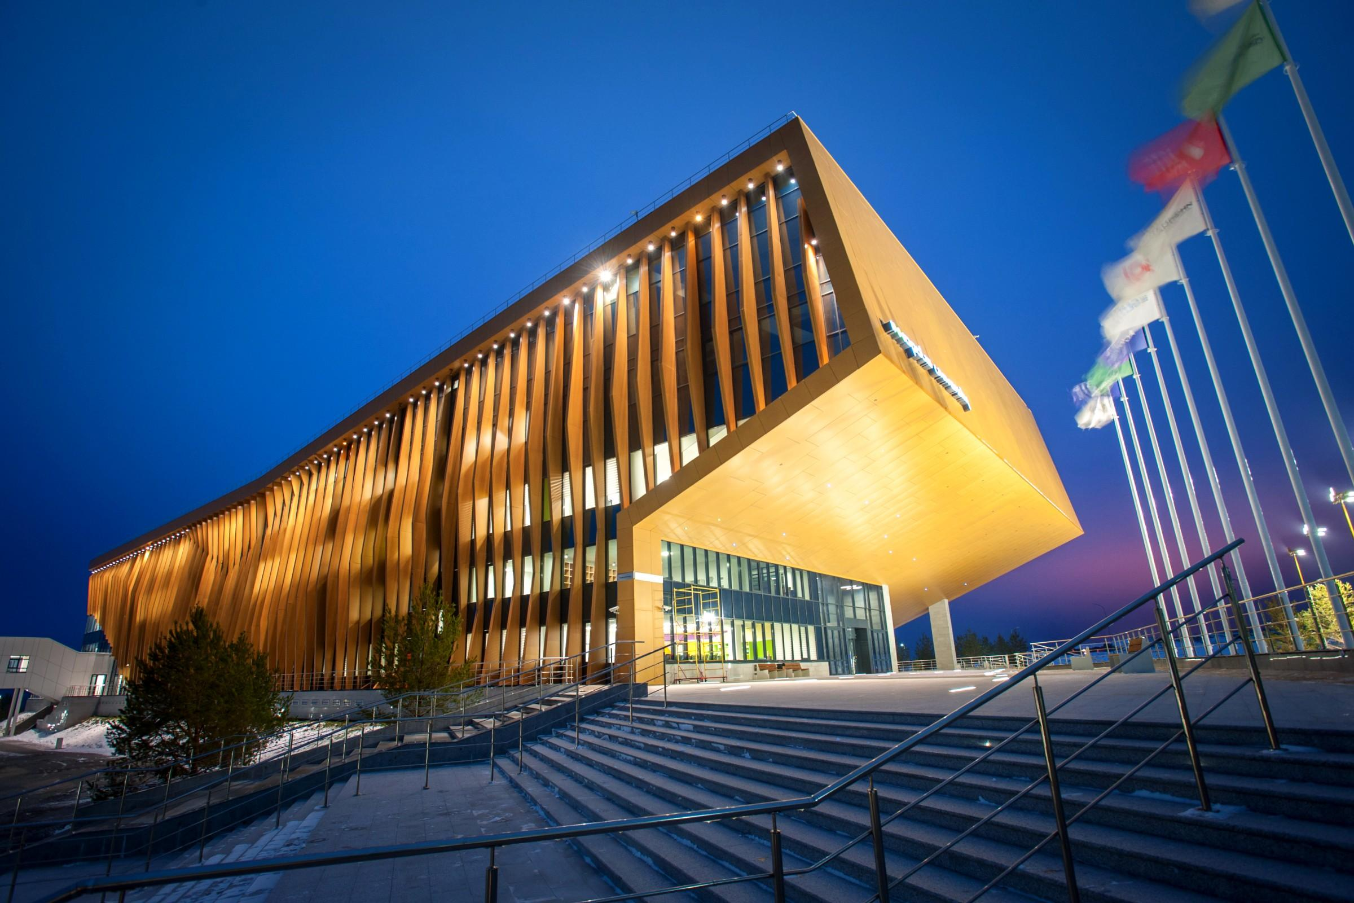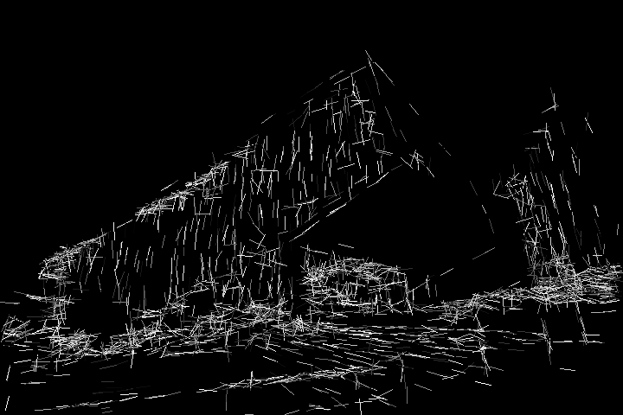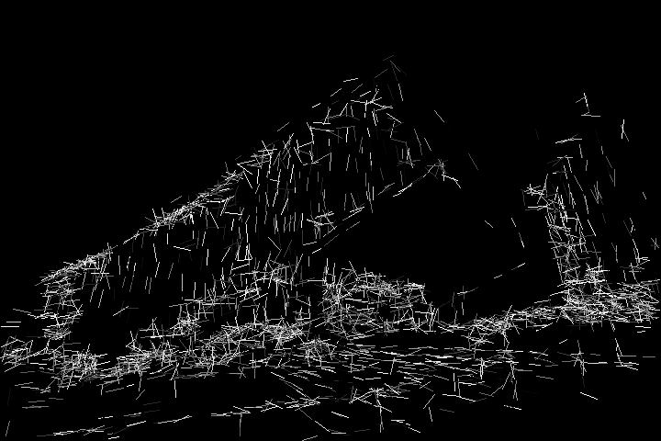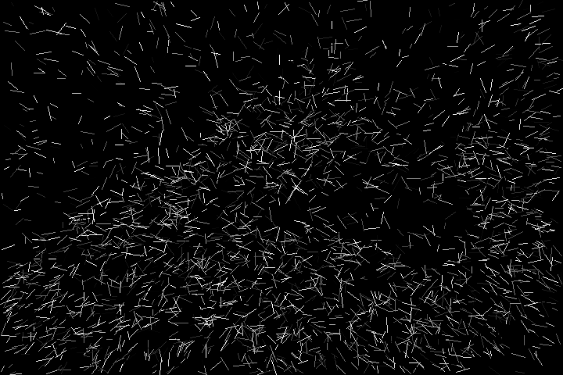



4. MSE

Population 5000

Length 5-20

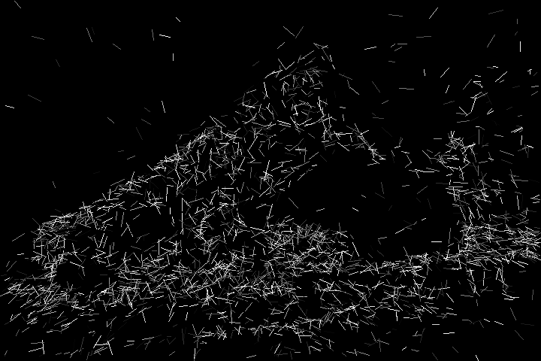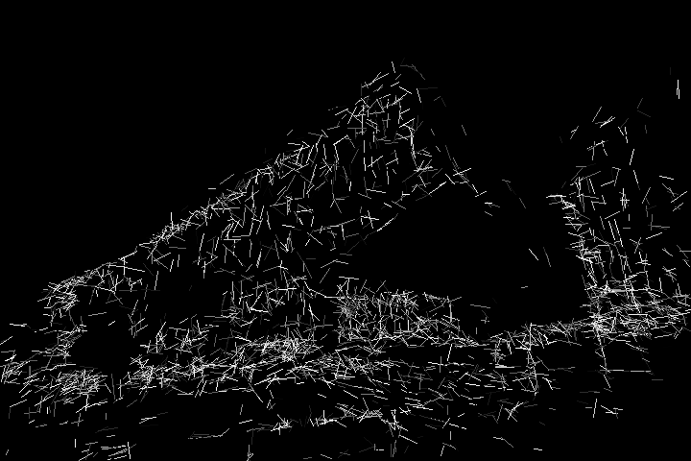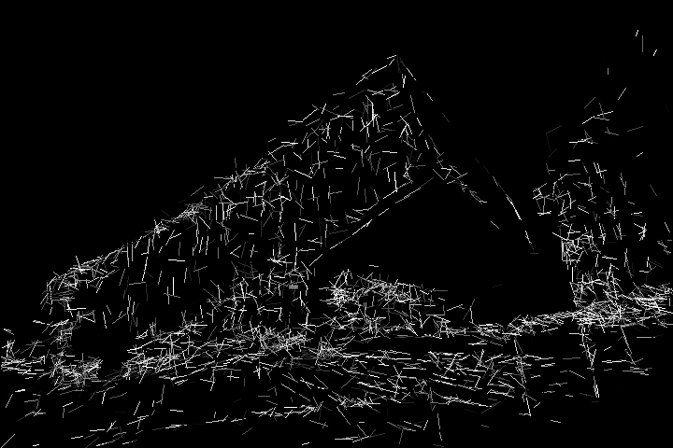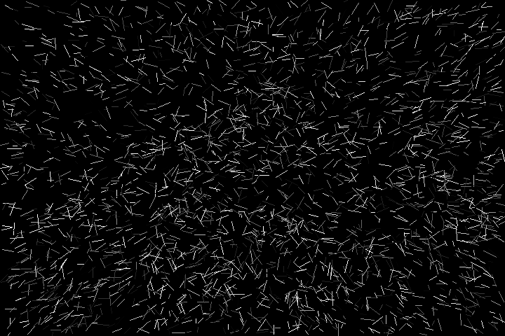

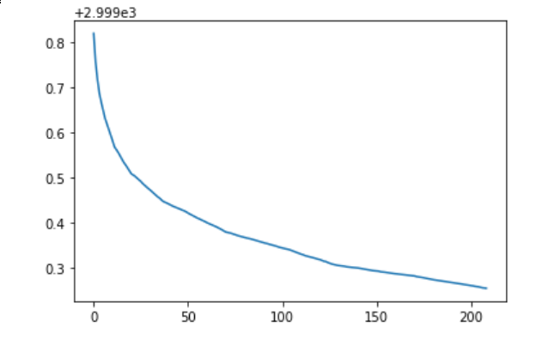

Conclusion

Evolutionary algorithms turned out to be efficient in drawing the arts. I considered 2 different approaches of evolution. Still I think there are some things to be done in future:

1. Rewrite the code to using GPU to increase speed of iterations
2. Try some other metrics to evaluate the quality of picture
3. Investigate some techniques of effective crossover